
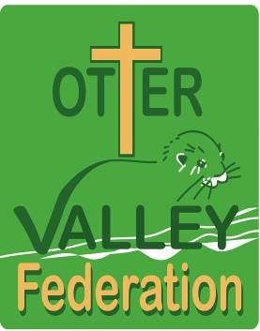
Note of Interest for a

Preschool Place

Please complete this form if your child is not yet old enough for you to make a nursery application.

Please check on the Citizens Portal to see if you are eligible for two-year-old funding and a nursery free school meal. Also, check your eligibility for funding if you are working as this will be needed when completing the application form.

Childs Details
First name:

Last name:

Date of birth:

Siblings Name/s (brothers and sisters who come to this school)
First name:

Last name:

Date of birth:

First name:

Last name:

Date of birth:

First name:

Last name:

Date of birth:

Parent/Guardians Details
First name:

Last name:

Address:

Phone Number:

Email Address:

Relationship to the child:

Privacy and Data Protection
Your personal data is being used by us because you have showed an interest in applying for a place in our school nursery when your child is old enough. We undertake to ensure your personal data will only be used in accordance with our privacy notice which can be accessed at the school office. Please confirm that you give your consent to the school using your personal data as outlined in our privacy notice, by signing below.

Applicant’s signature:

Date:

You have the right to withdraw your consent at any time. Should you wish to withdraw consent, please contact Nikki Meyer mrs.meyer@ottervalleyfederation.org
If you wish to exercise any of your rights under the General Data Protection Regulation, please contact the schools Data Protection Officer Alvin Scott at dpo@devonmoorsfederation.devon.sch.uk

If your circumstances change you must recheck your eligibility.

